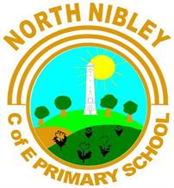 |  | North Nibley Church of England Primary School, The Street,  North Nibley, Glos. GL11 6DL  Tel: 01453 542600 www.northnibley.gloucs.sch.uk  admin@northnibley.gloucs.sch.uk  Head Teacher: Steven Hodgkinson


NIBLEY NEWSLETTER
^{26th} April 2024
PERSEVERENCE IS OUR VALUE THIS TERM
.
Dear

The Spring Fayre is almost upon us - it is a great chance to have fun in the sun, eat food from the BBQ and have good old fashioned merriment. On Friday 10th May (the Friday before SATs) we will be having a non-uniform day to help us relax and get ready for an unusual week. If you’d like to be in non-uniform then all you have to do is please bring in a prize for the tombola. Wine, beer, bubble bath, etc would be fantastic.

Sports Day will be held on the 13th June this year. We will have Sports competitions in the morning and then all parents are invited to have a big picnic on the field followed by the traditional races. FONNs will be providing refreshments so promises to be an amazing event so please do join us for lunch and an afternoon of sports. Who will lift the trophy this year?

Class 4 spent Thursday morning over at the Church with Rev. Lesley Hewish. We learnt about baptism and why Christians might choose to baptise a child or to have an adult baptism. Some of us were even involved in ‘role play’! Earlier in the week we also had a visit from School Liaison Officer (PC Hannah) who led a lesson on online safety.
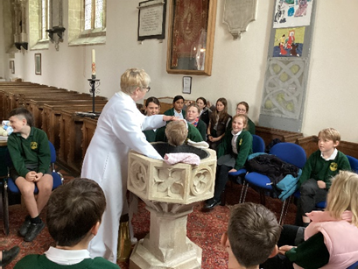

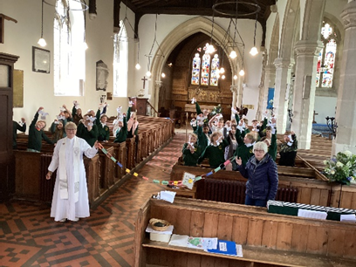

As always, we have had a busy few weeks in Class 1. We have continued our topic work 'Spring on the Farm'. We had a go at drawing some large scale maps of a farm and tried programming the BeeBots to travel to different parts of the farm. This week we have been learning how to make moving parts on our pictures and used split pins to make farm animals with moving limbs. We had a great but messy time in forest school doing mud painting, experimenting with which consistency made the best paint.

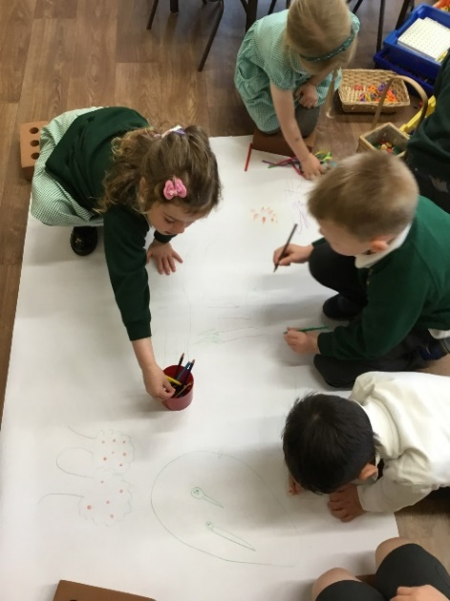
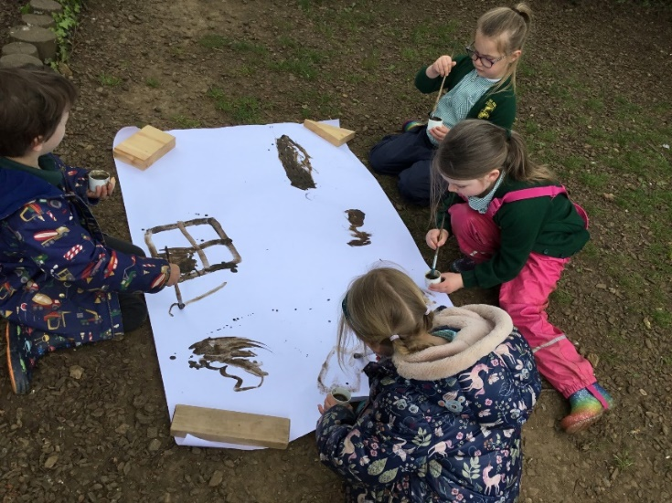

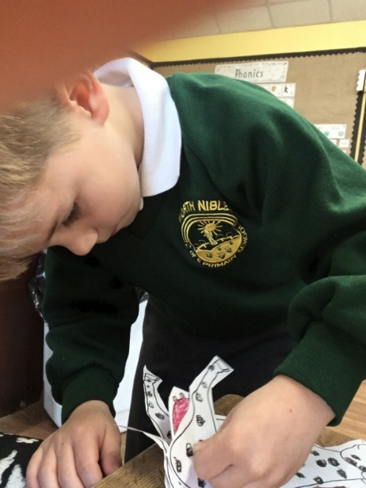

This week Class 2 have been looking at the achievements of Brunel and how he constructed the Clifton Suspension Bridge. We had a go at creating our own suspension bridges using junk modelling. We thought about how we would get our bridge to stay up in between the two bridges and what we could use as our towers.

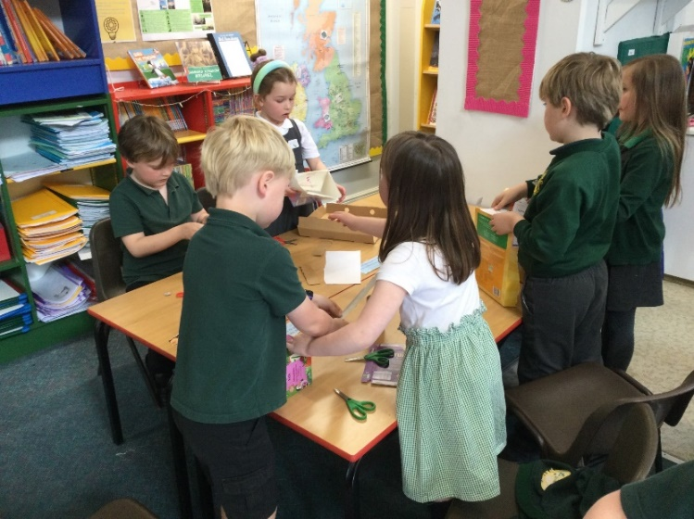
We also were exploring axels and wheels this week in our DT lessons and learning how vehicles move. We practiced making some axels and wheels and even attached a chassis!
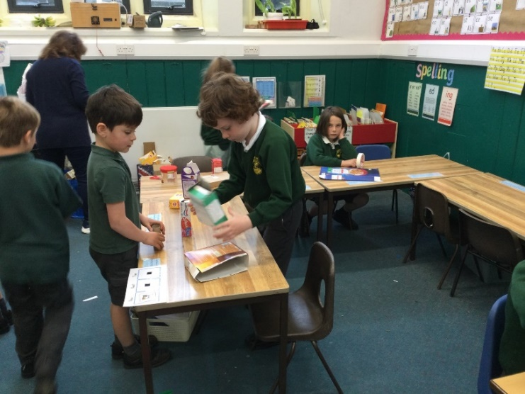

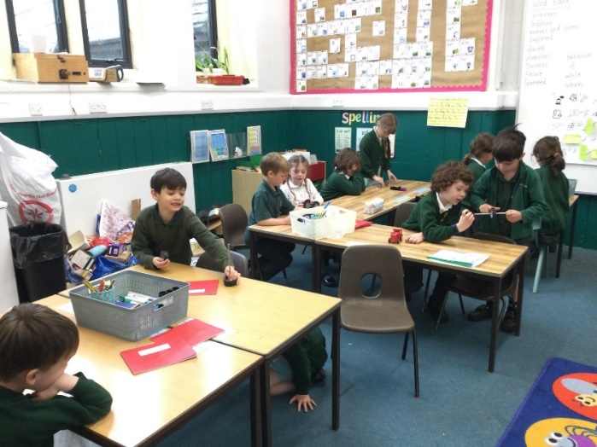

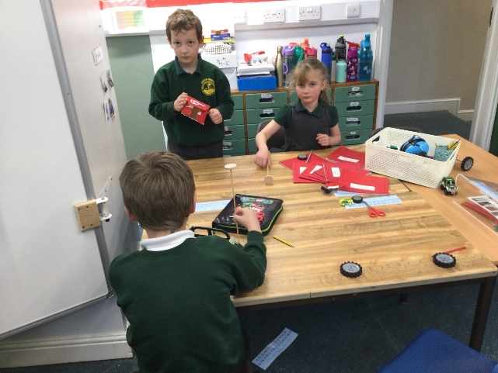

A massive thank you to the adults who came along to the maths morning. The children were great at demonstrating how we use manipulatives (resources) in maths lessons and the adults who came were very brave to have a go themselves and question the children! The PowerPoint is on Dojo for anyone who is interested and I will hopefully run a similar workshop at the start of next year. Any feedback would be greatly appreciated! Thank you.

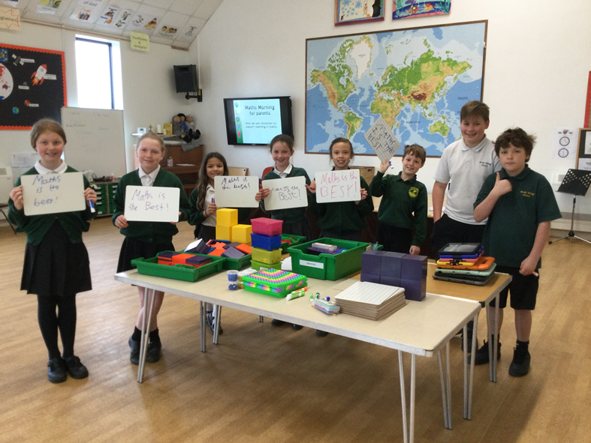
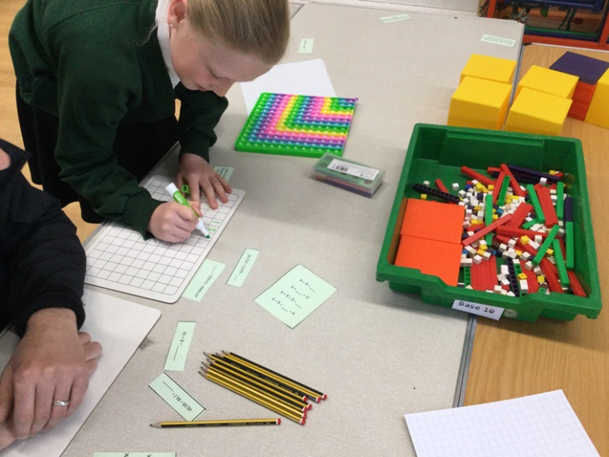

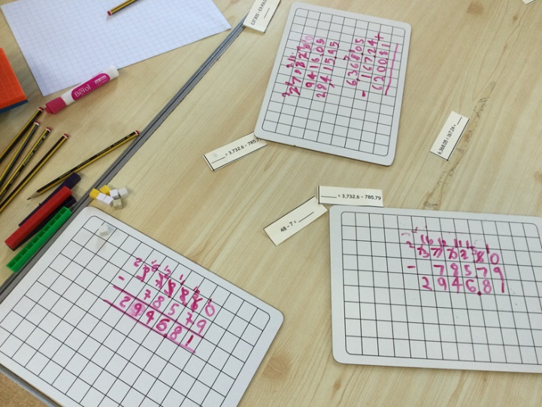

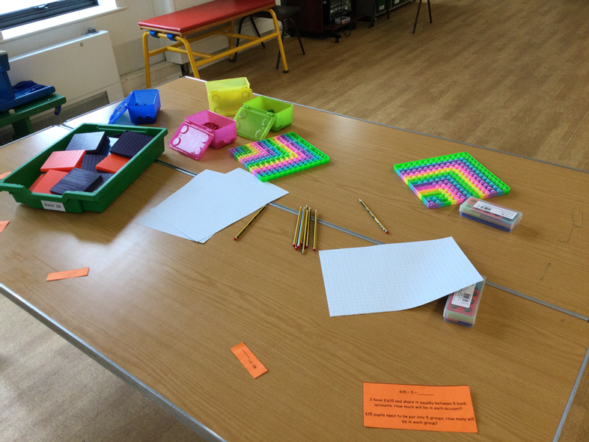
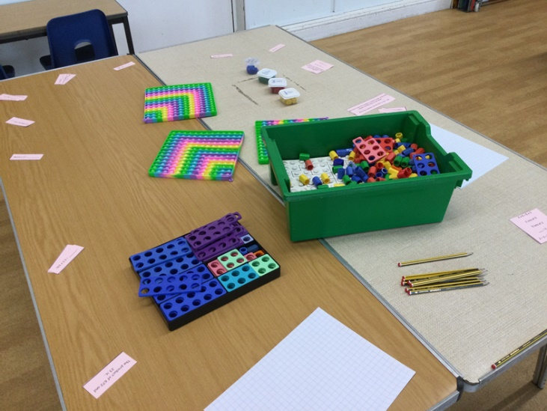

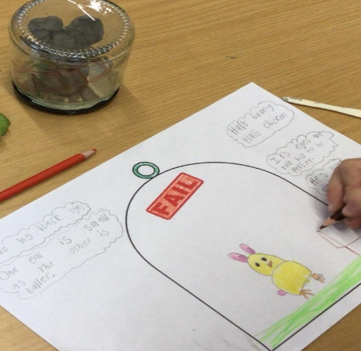
Class 3 have been creative this week! We have made our own 'failed pets' out of clay that will feature in our very own stories based on The Barnabus Project. I think I can safely say all the children have loved this book and have really enjoyed doing some amazing work based on it so far. Their pet creations are so imaginative and they've created them with such care. We are looking forward to sharing the stories they write over the next couple of weeks!
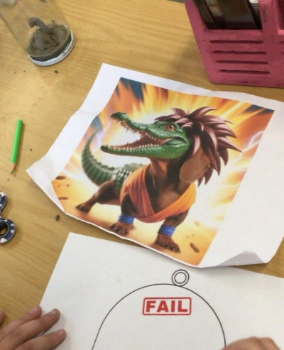
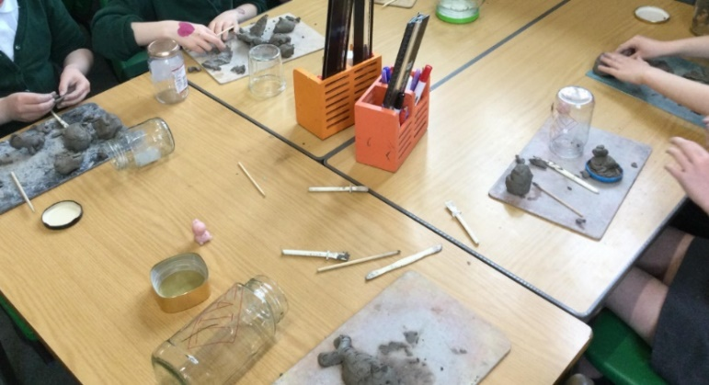

STARS OF THE WEEK AWARDS

Class 3
Ted D for effort and progress in maths - especially in fractions work.
Freya for enthusiasm in computing creating branching databases.
Erin for always having beautifully presented work but especially in history this week
Rex for great work in maths when counting and comparing amounts of money.
Ava for being so proud of your English work using expanded noun phrases and wanting to share it with me!
Oliver for the thought and preparation that went into creating your 'failed pet.

Class 4
Thomas and Josh – Working well together – supporting and pushing each other to achieve their best
Adele – improved focus and effort in maths, becoming more independent
Hettie – Working hard to volunteer answers and join in class discussions.
Otis – Asking good questions to further his knowledge and understanding

Class 1
Freddie - for great participation in group work.
Jules - for great attention to detail in art work.
Henry - for always being polite and helpful.
Pip - For always listening and following the class rules and routines.
Sammy - Fantastic enthusiasm and effort in drawing club.
Malachi - for showing great creativity when mud painting in forest school.

Class 2
Lyra- Creating a great letter to Rosie Revere's teacher.



Most improved last week : Sophia
Most improved this week : Freya

Barnaby ran to Cam Woodfield.
Lydia ran to Minchinhampton.
Charlotte TT ran to Slad Village.
Freya ran to Brimscombe.
Luke ran to Standish Woods.
Riley ran to Honey Hill.
Ava P ran to Nailsworth.
Posey ran to Honey Hill.
Joe D ran to Cam Woodfield and then onto Dursley.
Josh ran to Brimscombe and on to Honey Hill.
Lyra ran to Cam Hopton.
Trudy ran to Cam Everlands.
Joseph (class 2) ran to Cam Everlands.
Ngaire ran to Brimscombe.
Olive ran to Woodchester.
Otis ran all the way back to North Nibley.
Olivia ran all the way back to North Nibley.
Oliver P ran from Winchcombe to Cheltenham.
Martha ran to Cam Hopton.
Rebecca W ran to Pitchcombe.



Running club stars

Dates for your diary :

1
3rd May – School photos. Class & Year 6 individual photos
W/c 13th May – SATS week
17th May – Non-uniform day
18th May – FONNS Spring Fayre

3rd July – Music extravaganza
5th – 7th July – Nibley Festival

Term dates :
Summer 1 – 8th April to 24th May (6th May is a bank holiday)
Summer 2 – 3rd June to 19th July
Back in the Autumn – 4th September 2024 (2nd & 3rd are
INSET days)

